Sublime Text is a source code editor with a API, similar to that of Python, that can interact on multiple platforms. It supports many programming or markup languages, and its functionality can be extended to use plugins. These typically are maintained under a free software license and community built. It’s a proprietary software, which is software that doesn’t meet the criteria to be free or open source and license revenue accrues to the developer. Most people can use this software for free, without penalty, but it will frequently ask for financial support.

Recently, in March, they released the latest version or build, sublime text 3, which fixed the high CPU usage, fixed a crash of the command palette, and controlled tab completion. They frequently update with new builds in order to stay on the upmost technology.

Sublime Text supports many plugins and features, such as 22 different visual themes, including customization options, a minimap feature that allows a reduced overview to the right of the screen, a python-based plugin API, Goto anything allowing for quick navigation to files, symbols, or lines, project specific preferences, compatibility with language grammar, simultaneous editing, and cross-platform ability that includes OSX, Windows, and Ubuntu. The user only needs one license to use Sublime Text on every computer you own, no matter what operating system it uses. The program also offers a variety of screen modes, which allows the files or folders to be opened to the left of the screen for easier accessibility. The column selection and multi-select editing feature allows the user to select entire sections at once, or multiple cursor areas at once, to allow simultaneous editing. This allows for efficient coding. Snippets are giving the user the ability to assign keywords to the saved blocks of frequently used code. The user can then type the keyword and press tab to paste the block of code whenever they require it. Goto anything is a tool that allows users to switch between open, recent or project files and also navigate to symbols within them. Sublimes auto save capability prevents users from losing work. According to Wikipedia, “Package Control is a third-party package manager for Sublime Text which allows the user to find, install, upgrade and remove [plug-ins](https://en.wikipedia.org/wiki/Plug-in_(computing)), usually without restarting Sublime Text.” This manager will keep the packages up to date as well.

Some quick commands for some of these features: The user can also Use Multiple Selections to rename variables quickly by using the ⌘D is used to select the next occurrence of the current word.

For example, in the below pictures, by placing the cursor within multiple locations the user can change one variable more efficiently. Notice len -> length. 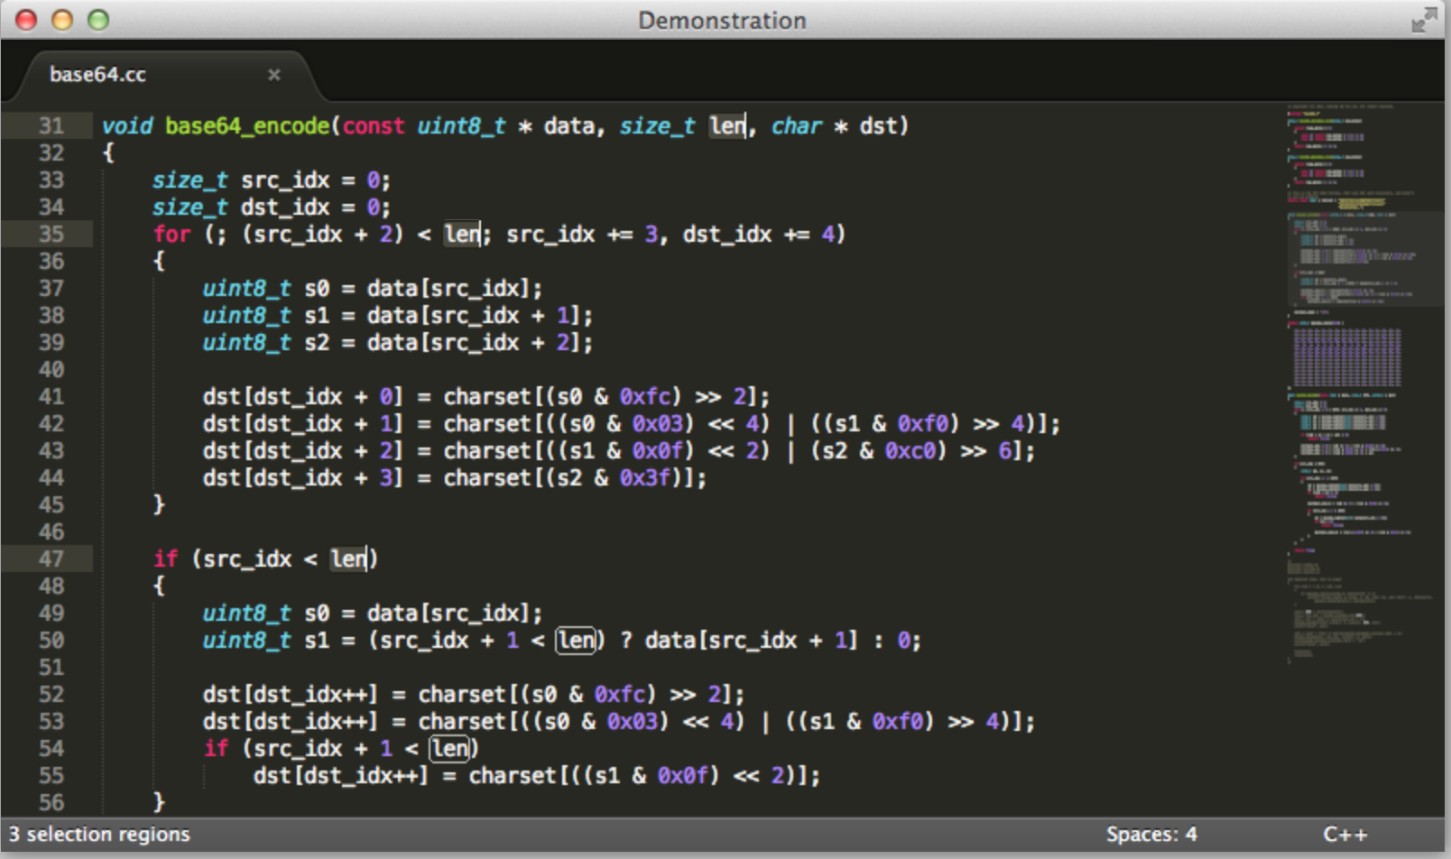

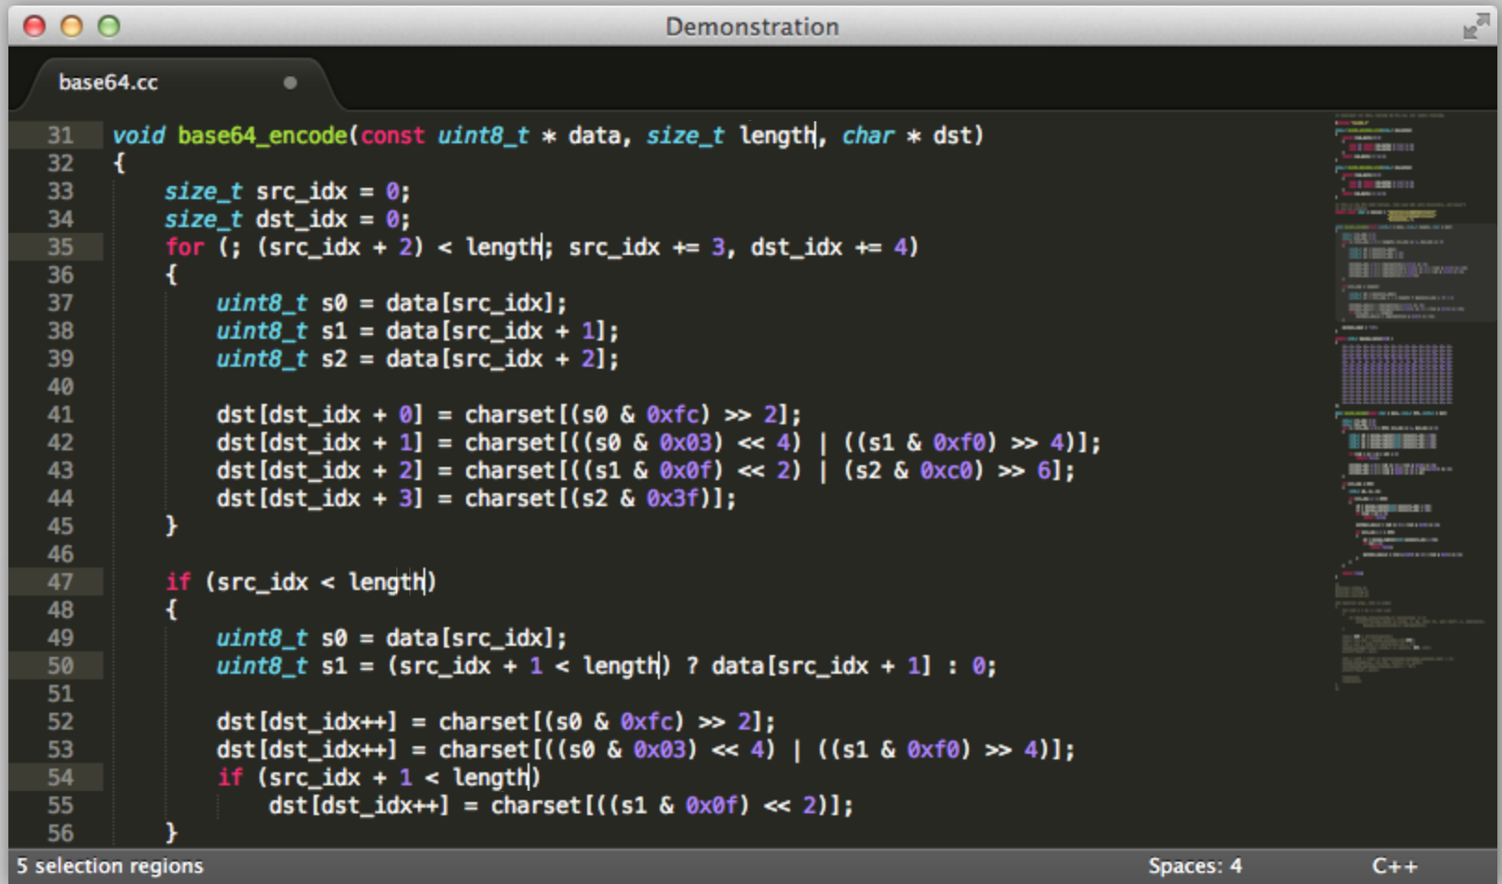

To make multiple batch using the ⇧⌘L is used to split a selection into lines, and each line is then edited simultaneously.

For example, below is a series of pictures to show how the lines are edited at the same time.

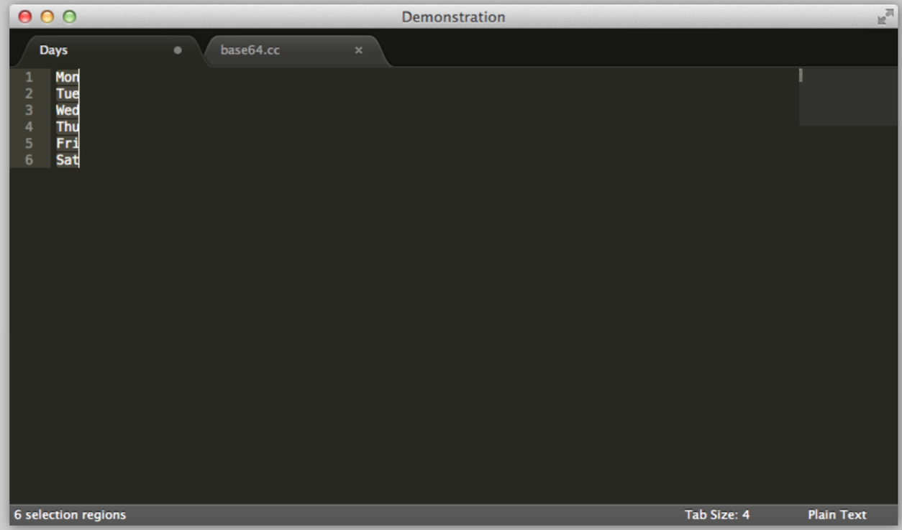

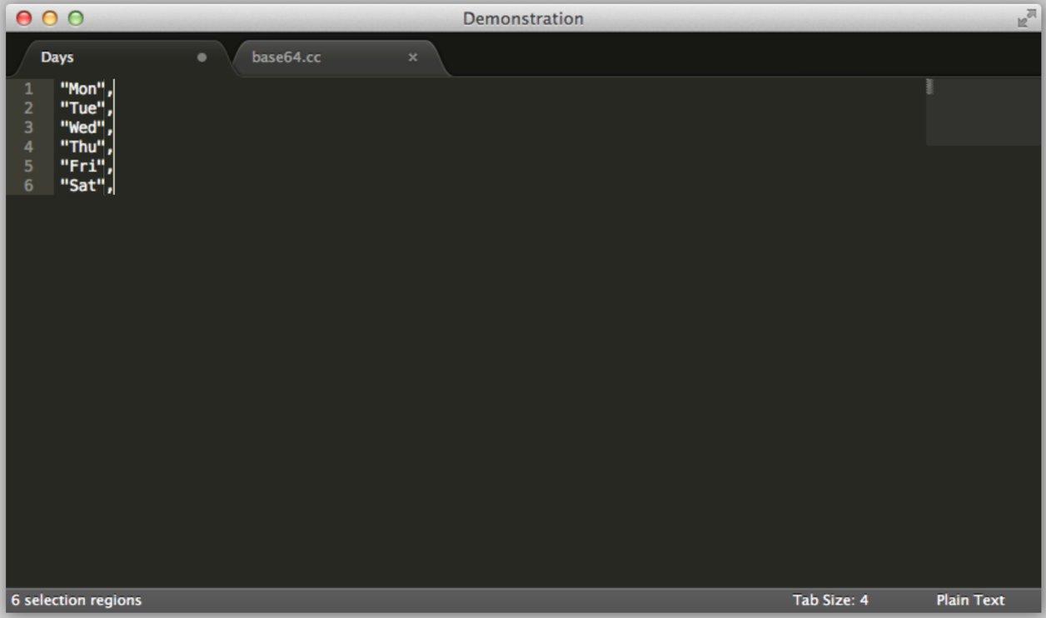

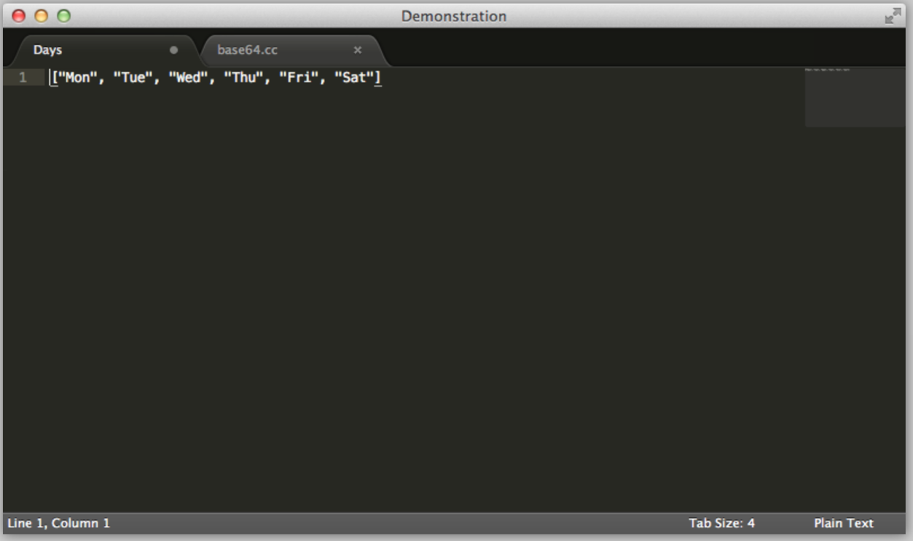

To make make the command palette give faster access to functionality, the user can select ⇧⌘P is used to show the Command Palette, "sspy" (short for Set Syntax: Python) is used set the syntax of the current file to Python.

For example, below shows a series of pictures that show how to access the command palette and importing.

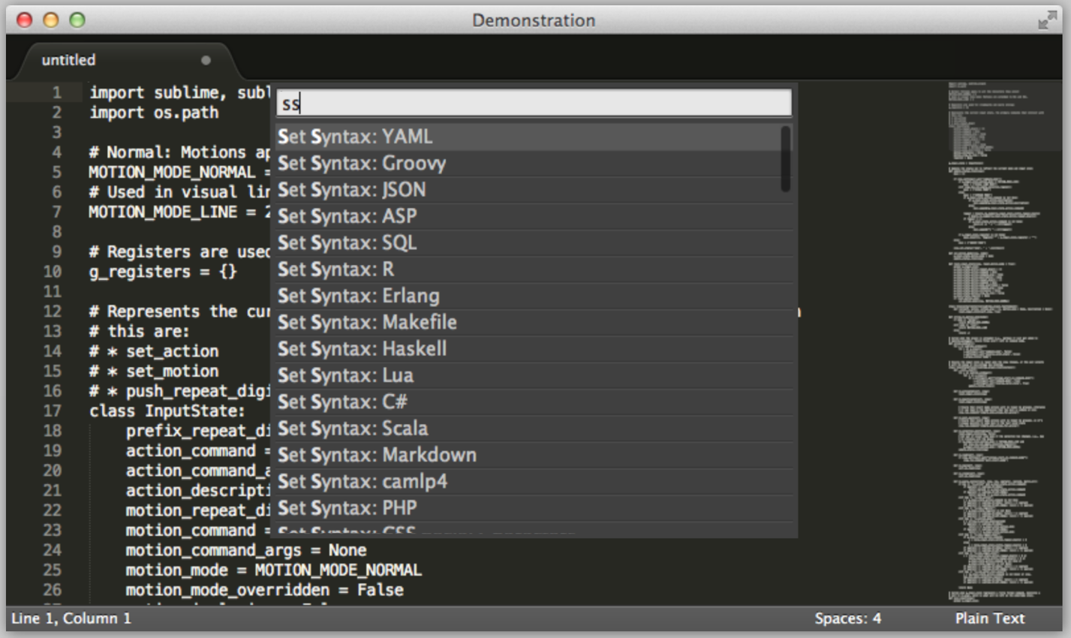

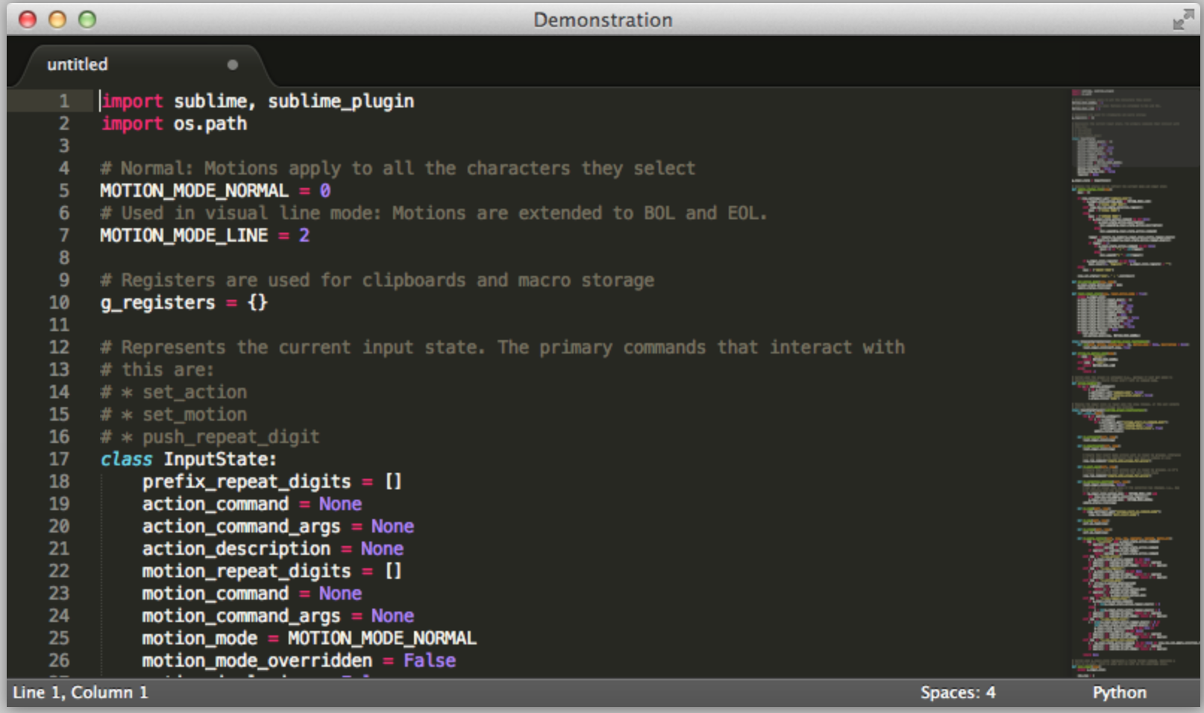

For the Goto anything, which allows the user to quickly navigate between files, ⌘P is used and typing then filters on file and directory names after using @.

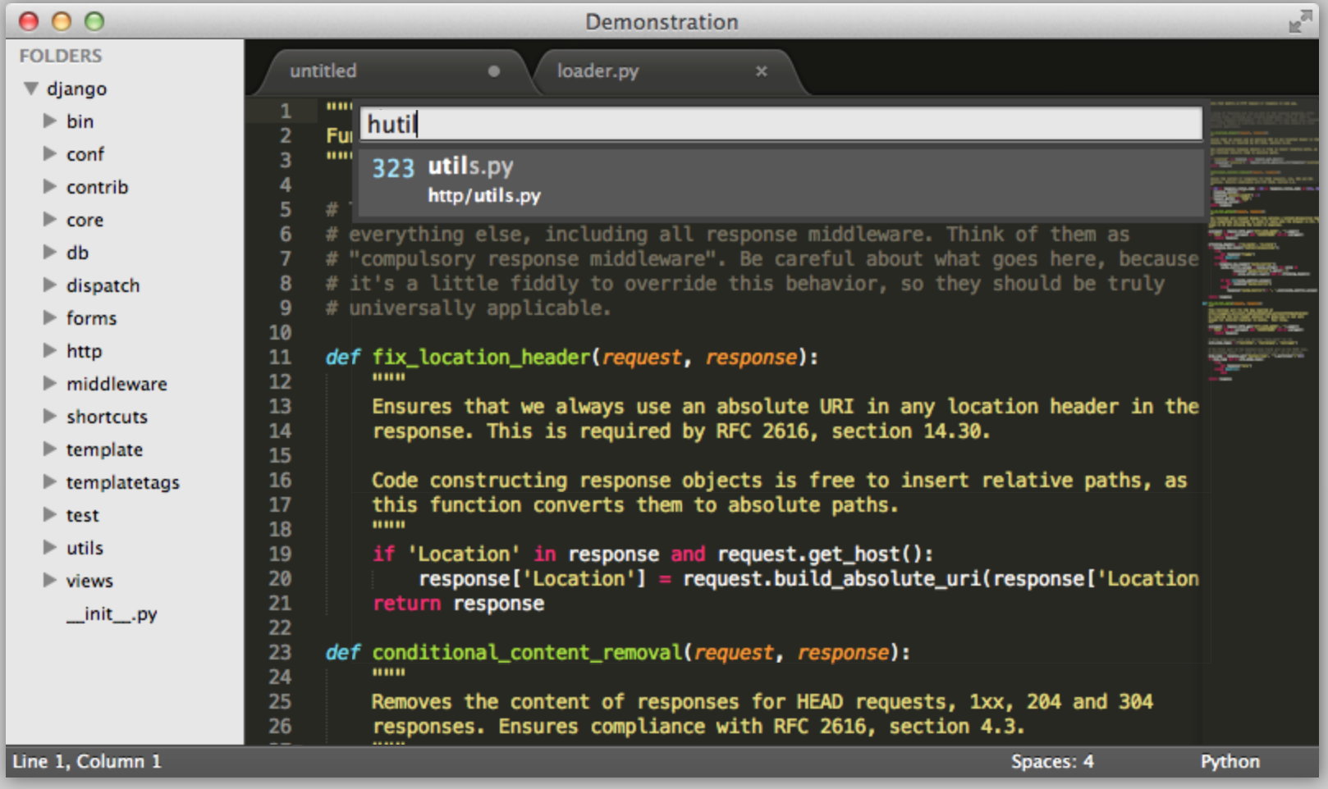

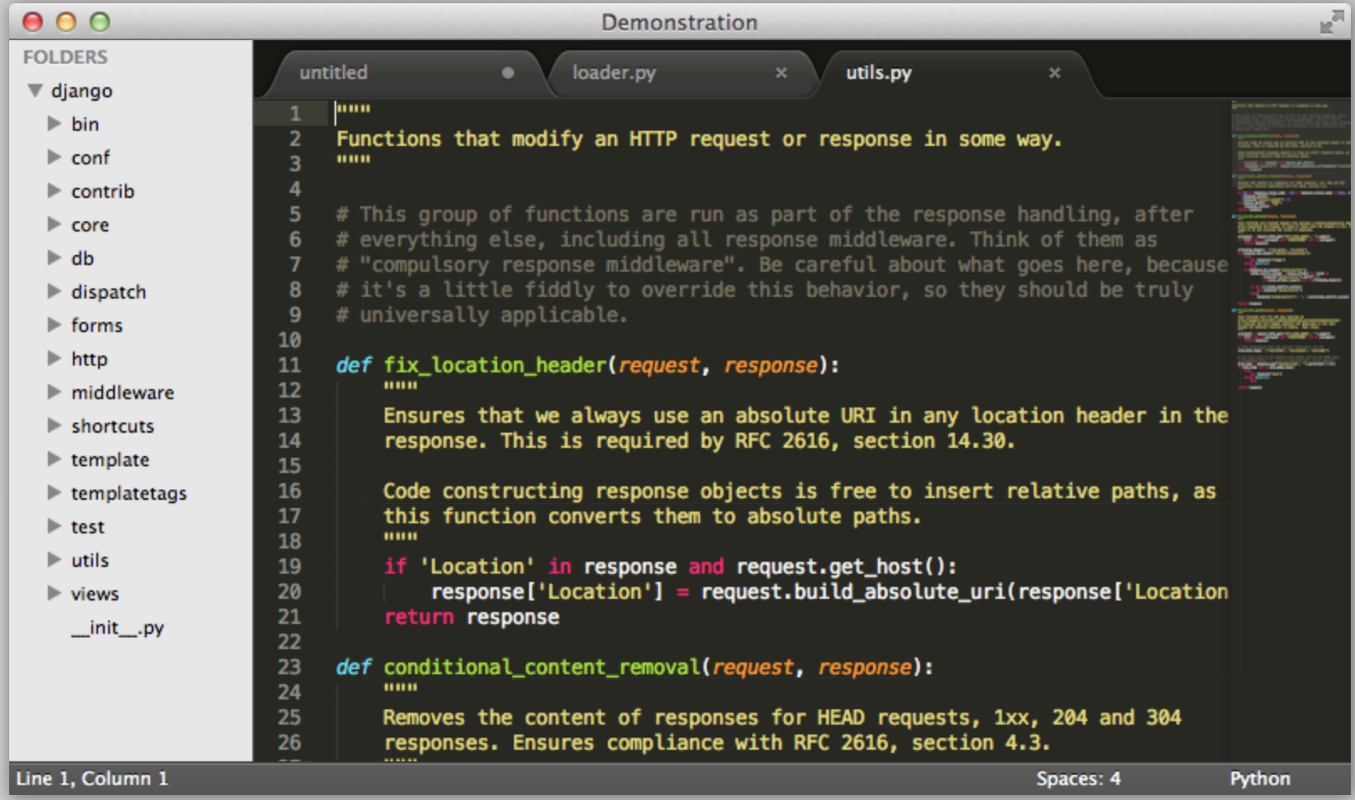

And lastly, the user can find and replace with regular expressions. For example, unwanted whitespace is removed by using the regex " +" to find groups of spaces, which are then selected simultaneously with the Find All button.

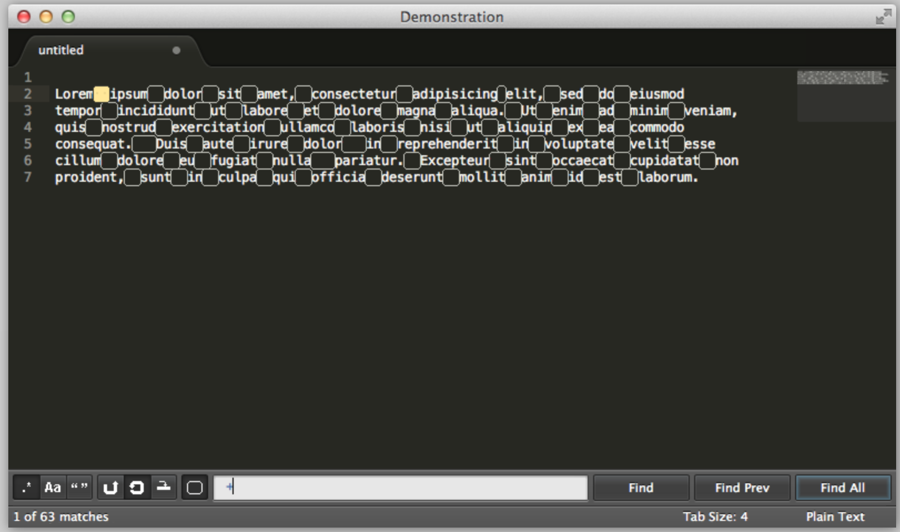

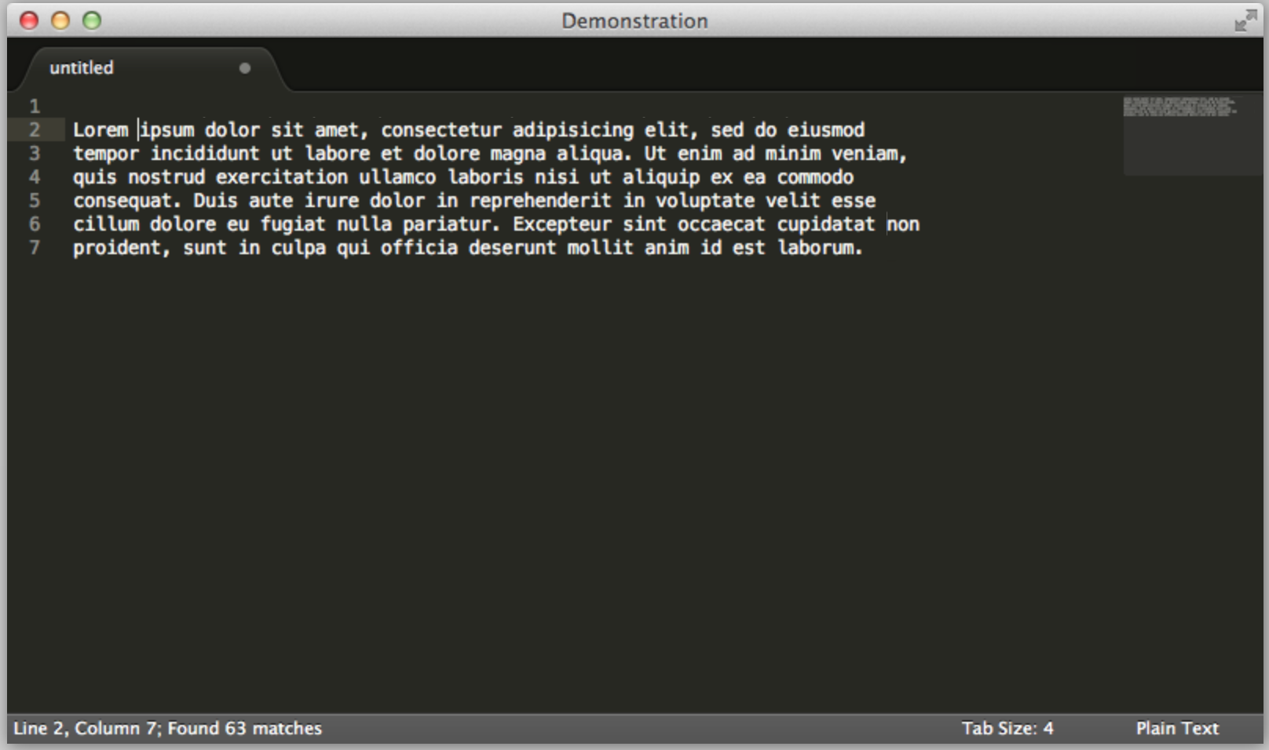

To download, simply go to <http://www.sublimetext.com> where you can select the appropriate operating system and select download. This website also provides an area to purchase the product. 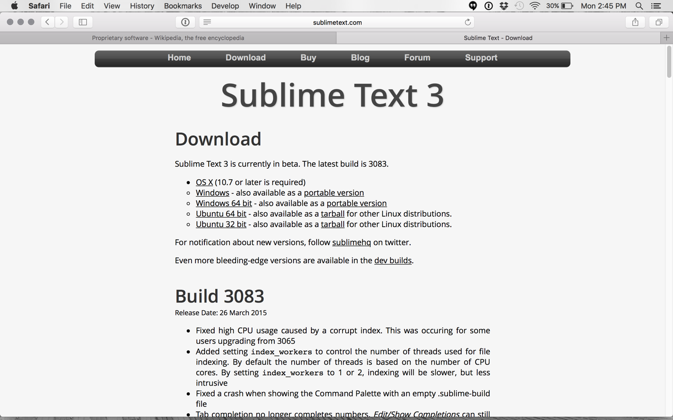For support see the blog and forum sections for information and the support section within the site as well for troubleshooting and other technical support questions.

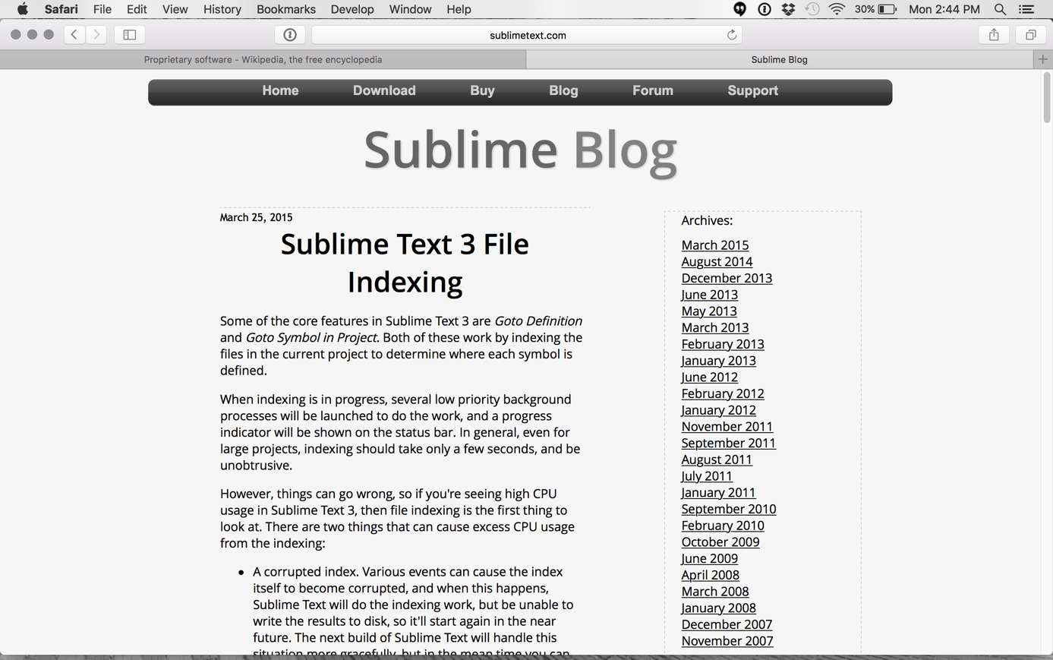

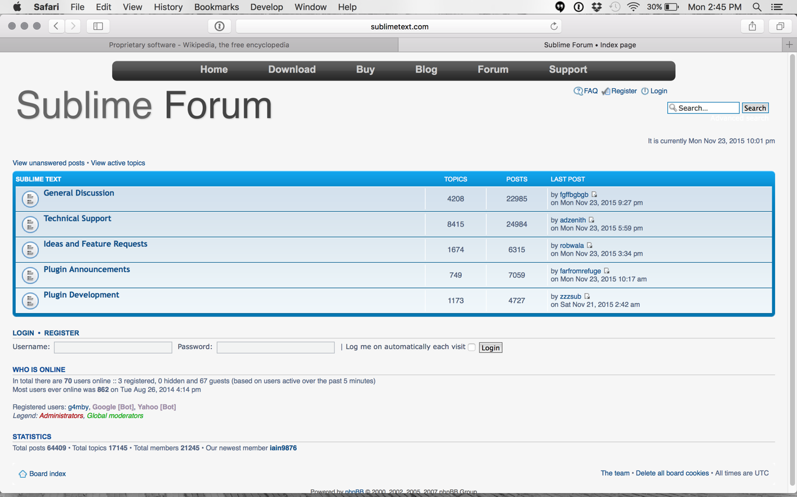

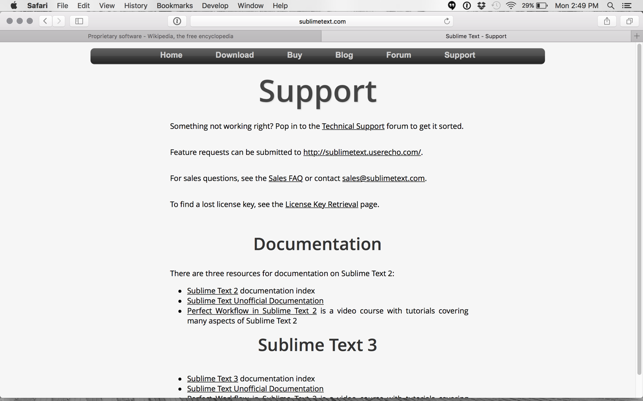

References:

<http://www.sublimetext.com/3>

<http://www.sublimetext.com>

<https://www.youtube.com/watch?v=zVLJfrIwEP8>

<https://packagecontrol.io/installation>

<https://en.wikipedia.org/wiki/Sublime_Text>

<http://docs.sublimetext.info/en/latest/basic_concepts.html>

<https://github.com/SublimeText>

<http://askubuntu.com/questions/172698/how-do-i-install-sublime-text-2-3>